Notice

PHPStorm (IDE)

What is PHPStorm ?

PHP Storm is an editor for PHP, HTML, CSS and JavaScript.

How to download it ?

First of all, you must click this link -> <https://www.jetbrains.com/fr-fr/phpstorm/>

And you should have this:

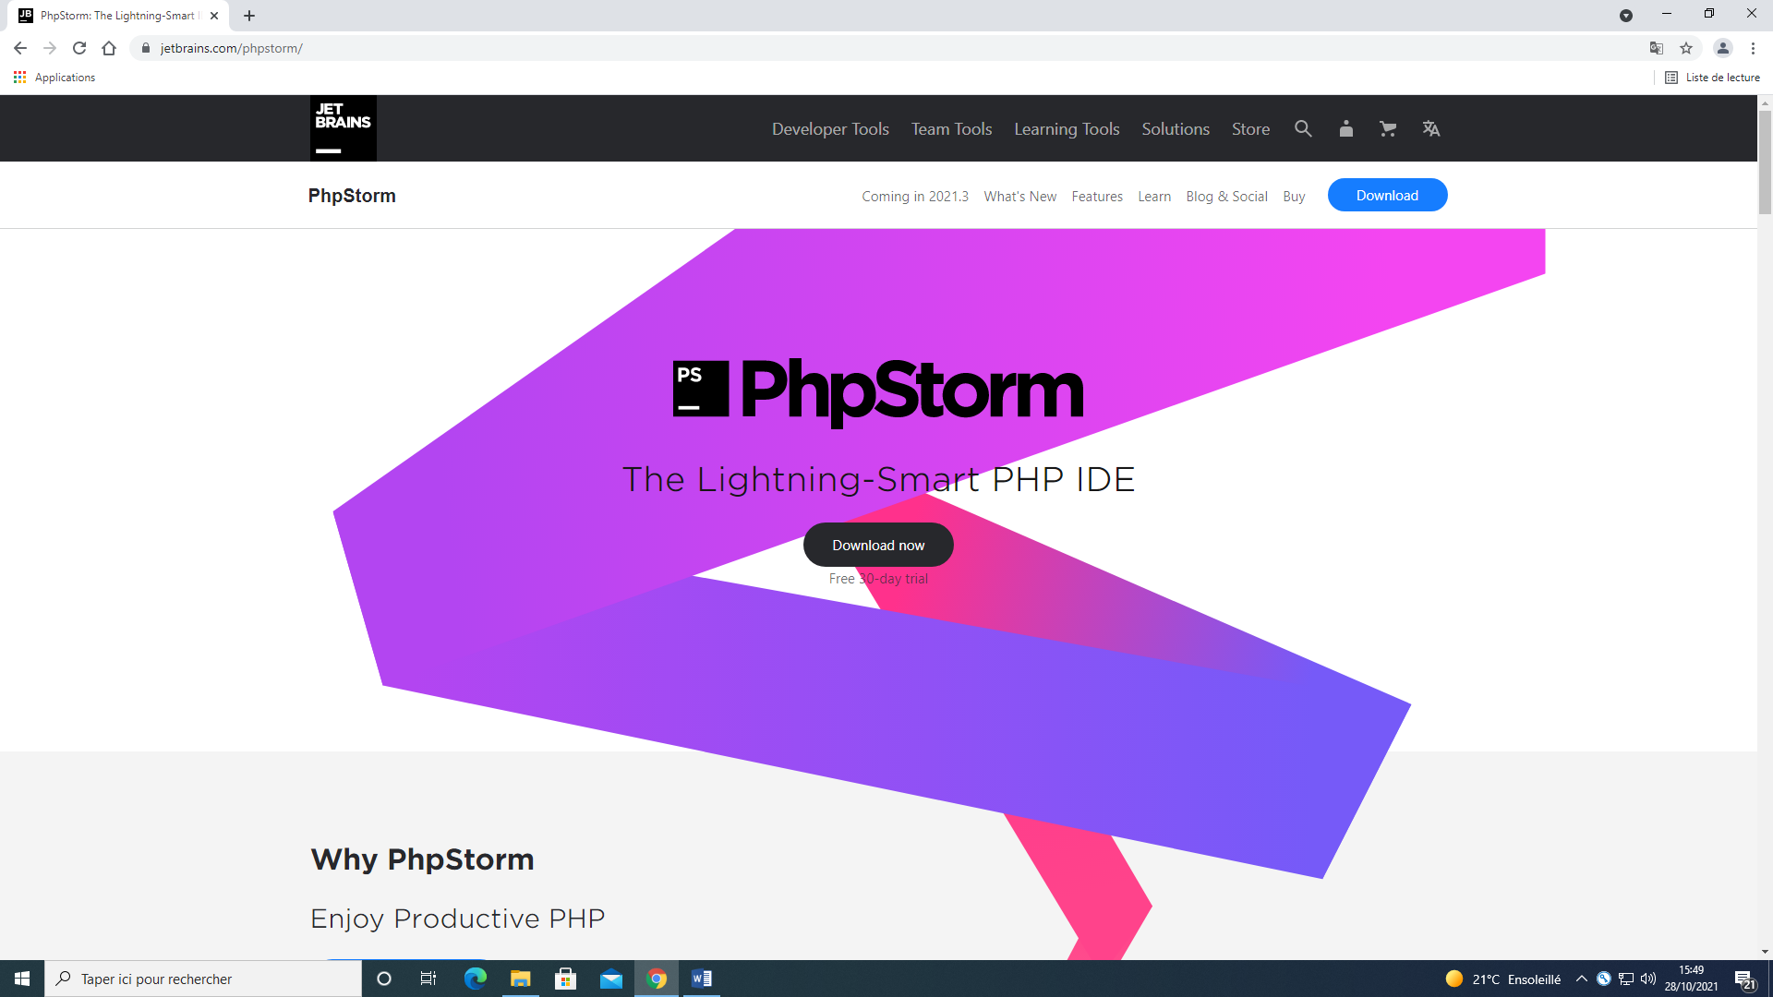

When you are here, click on Download and you’ll end up here and you just have to hit Download again :

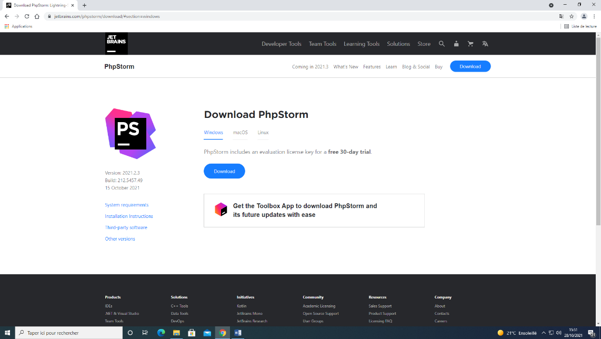

You will end up here and You click again on Download. It should start downloading on your computer.

You will see the download start on the bottom left corner and when it’s done just click on it to start it. It will look like this:

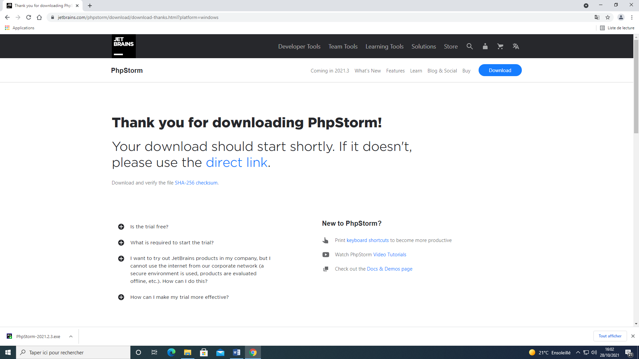



After clicking on this PHP Storm will open and you will see this:

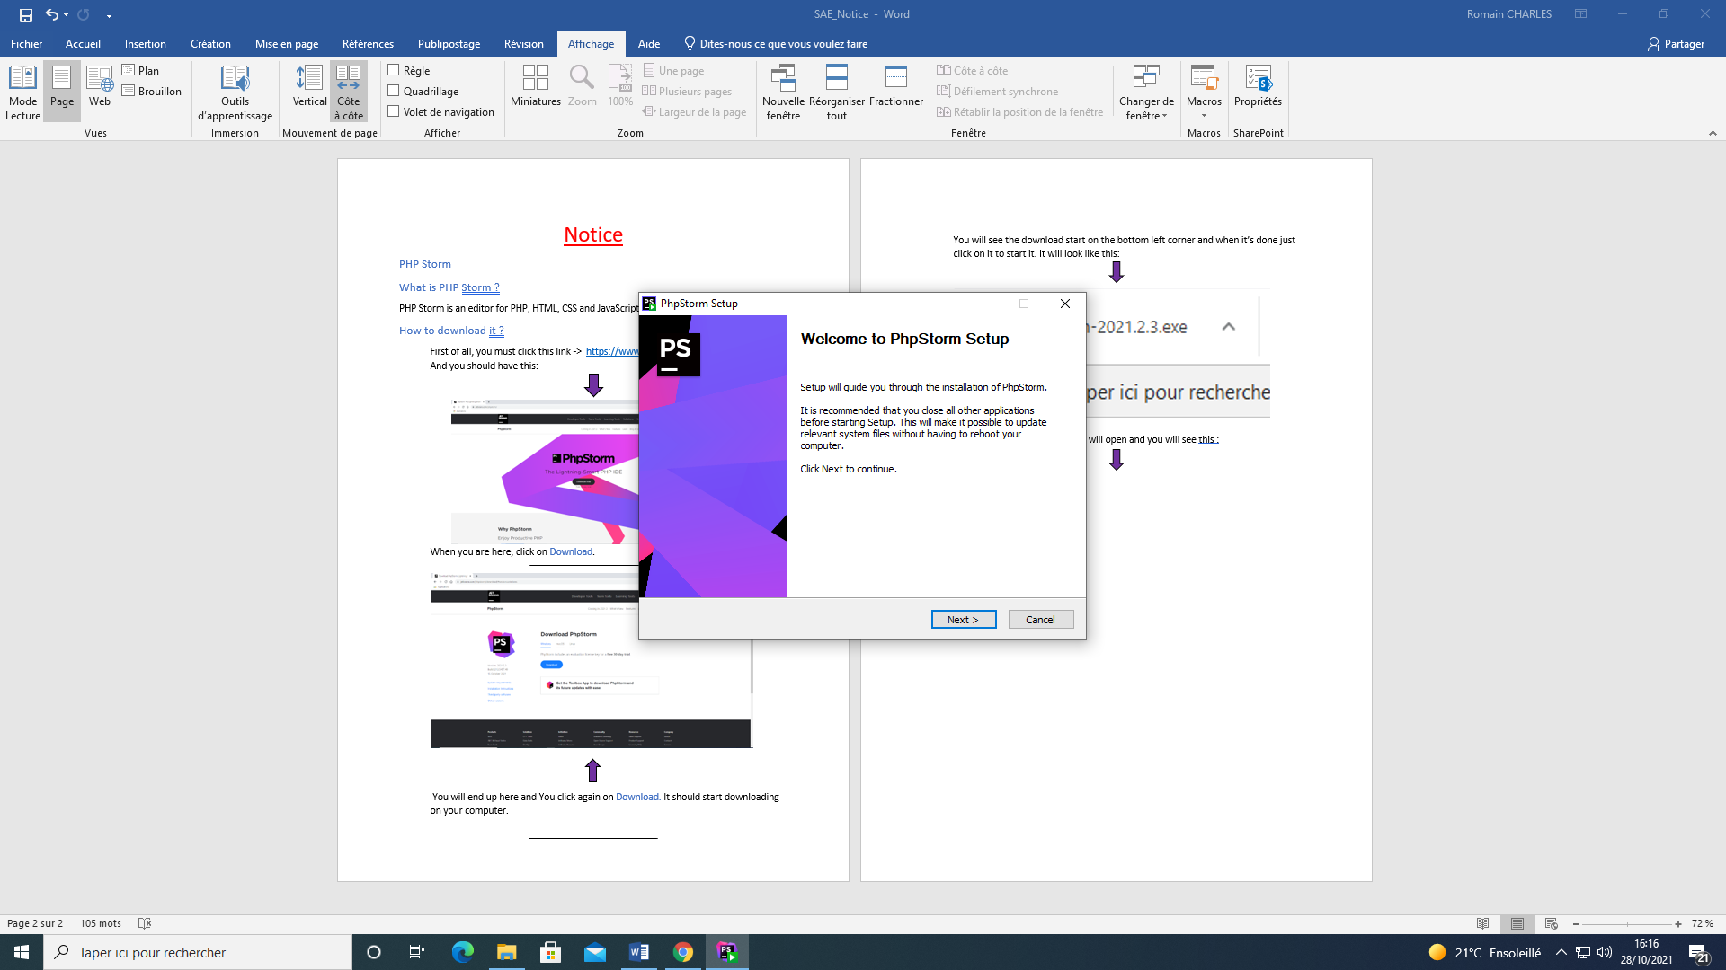

Hit Next until you have this and you will have to check these boxes:

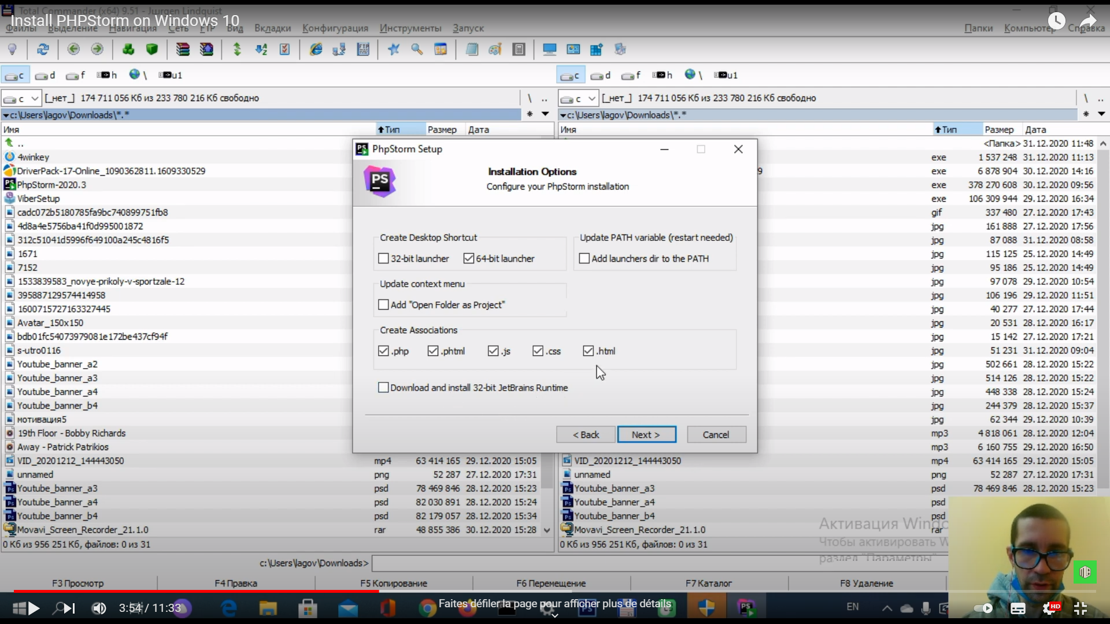

 After hitting Next you will have this look if it’s on JetBrains and click Install :

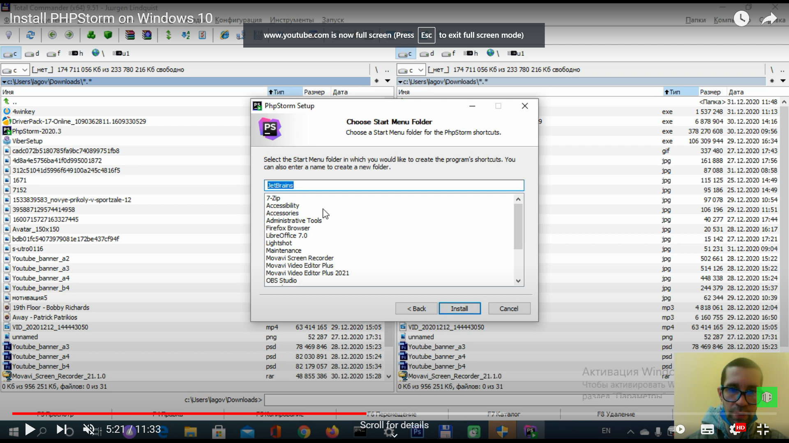

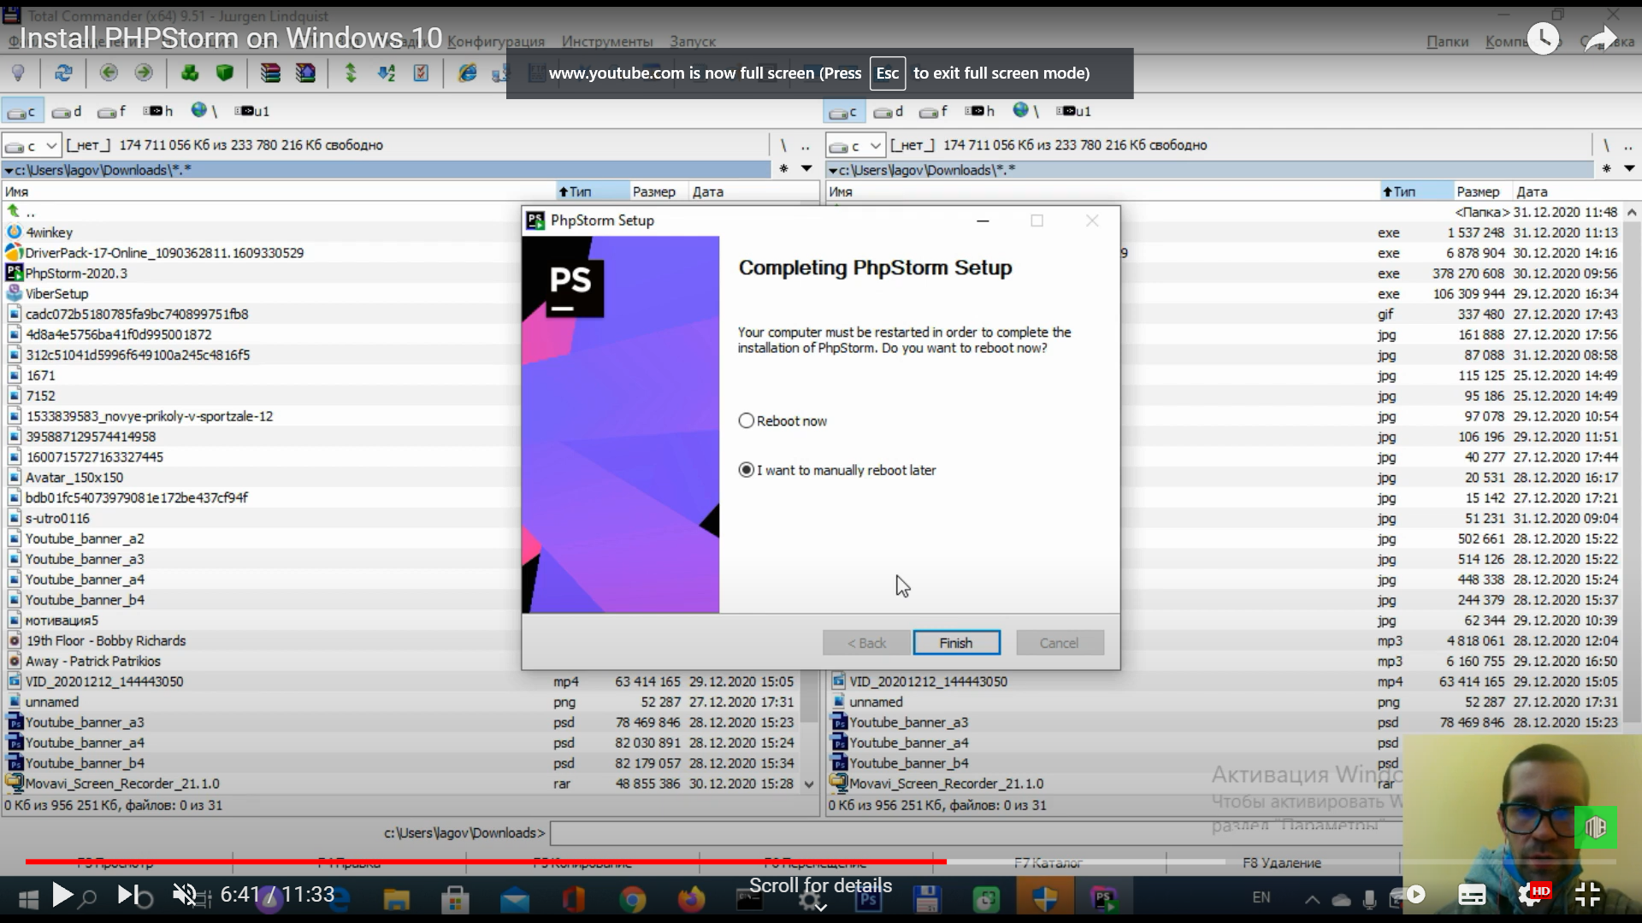Finally you’ll have this window just click on Finish and you are all set to use PHP Storm:





How to use PHP Storm ?

Well first open PHP Storm and this window should pop up:



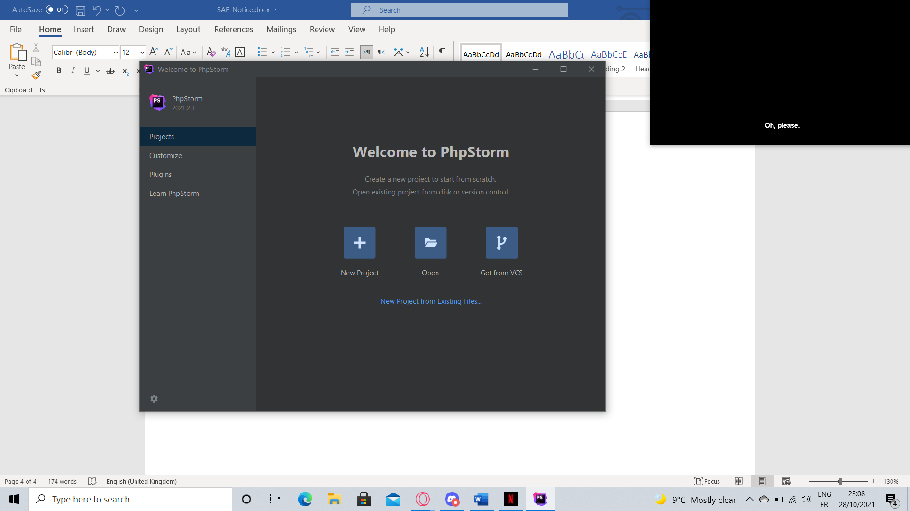

Click on New Project and you will have this on your screen :

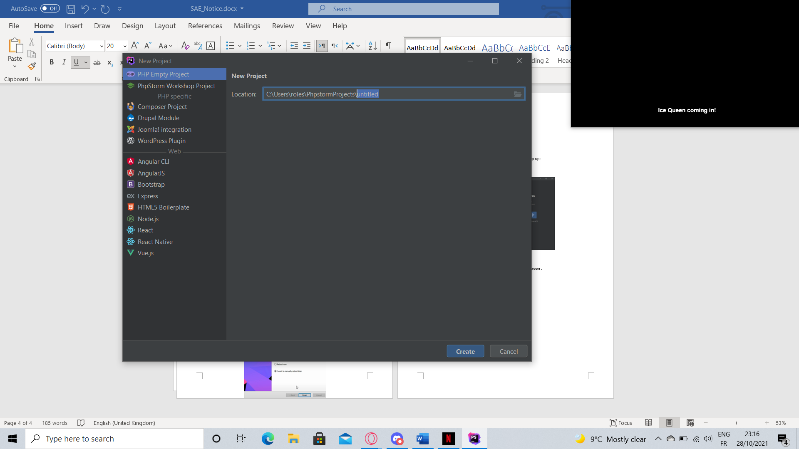

If you want to name you project just replace Untitled (it’s highlighted in the previous picture )by the name you want after that just click on Create on the bottom right corner and you should have a something like this :

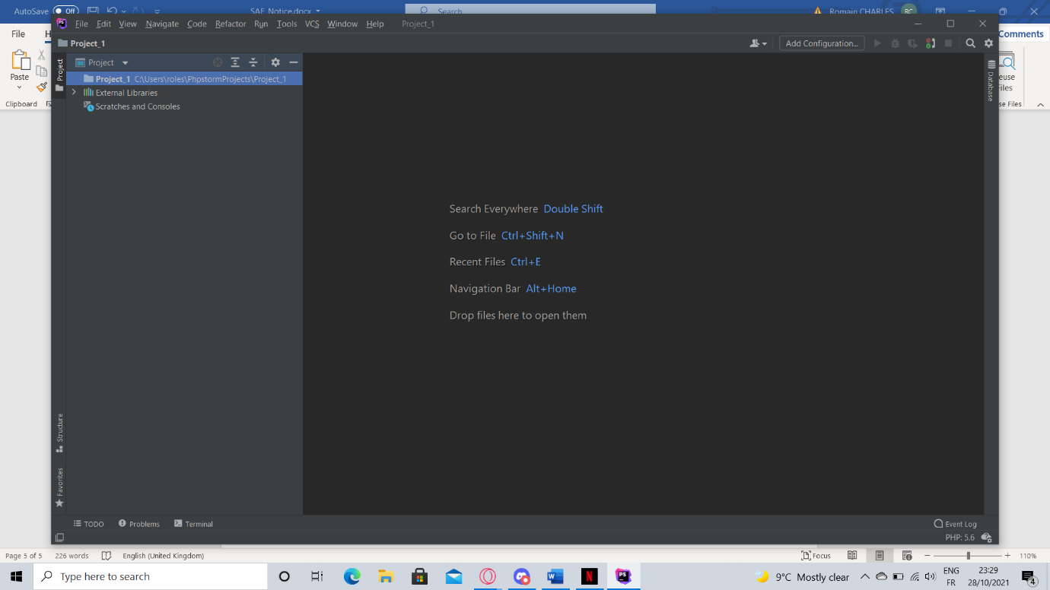

After this you’re going to Right-Click on your project then on New and it should look at little bit like this :

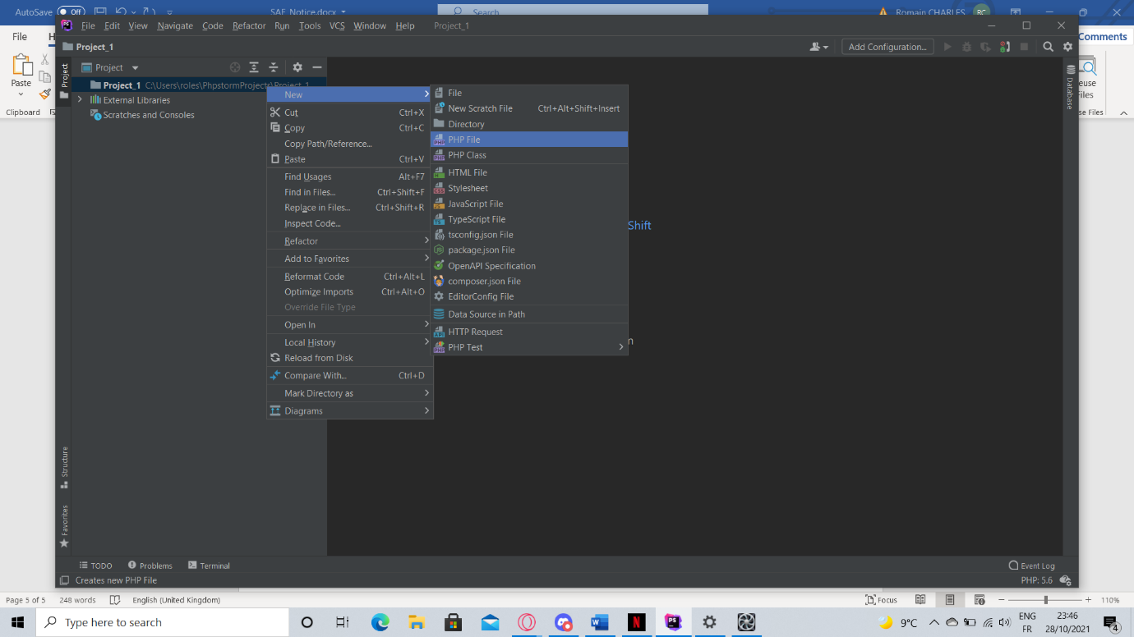

Click on PHP File a little window will appear where you can name your project like this :

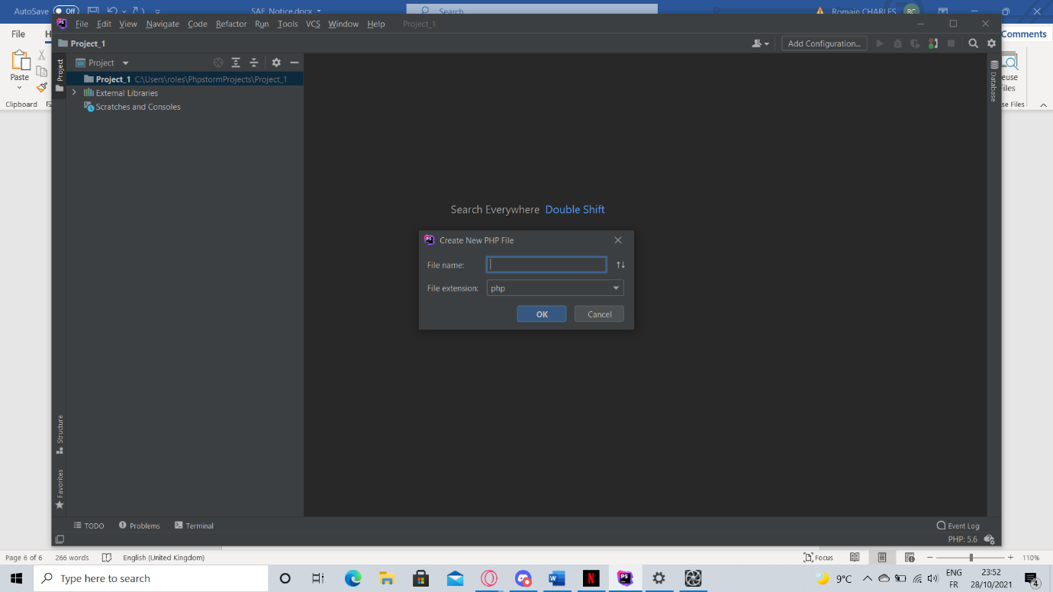

Click OK and you’re all set, you can code with PHP Storm .



MariaDB (Data Base)

How to install it ?

First of all click on this link <https://mariadb.org> and u should end up here:

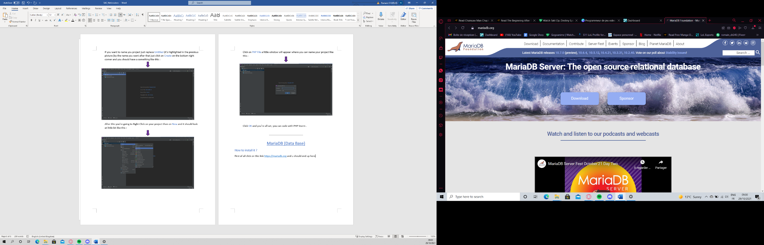

Click on Download and you’ll be there :

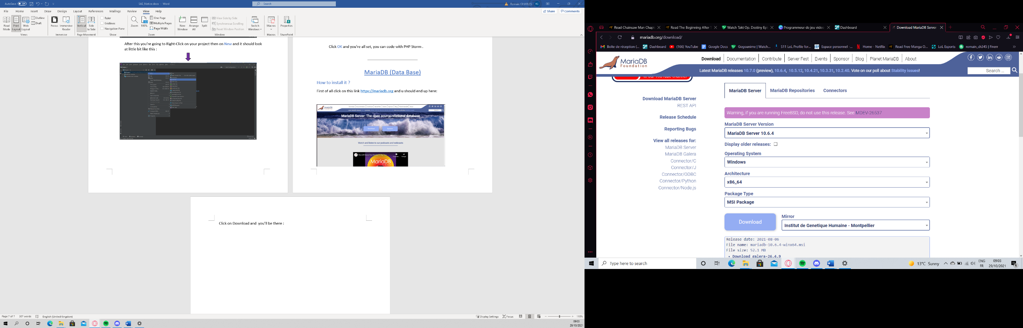

Hit again Download and you will see the programme starting to download in the bottom left corner .When it’s done double click on the programme and this should pop up :

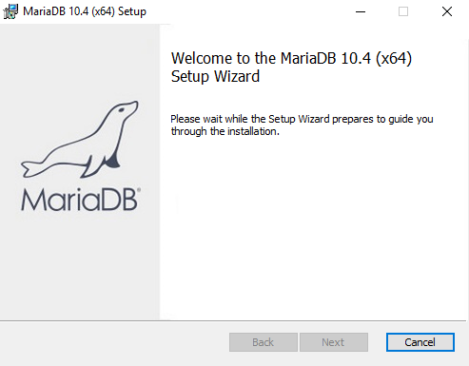

After that hit Next and then you are going to have this ( unless you want to read it) just scroll down and check the box In the bottom left corner to accept it and then hit Next :

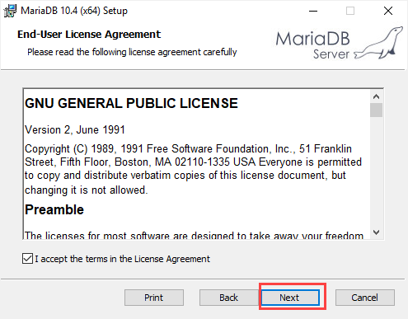

Just hit Next until you end here then enter the password that you want and then check the box in the third red box to enable UTF 8 then click Next :

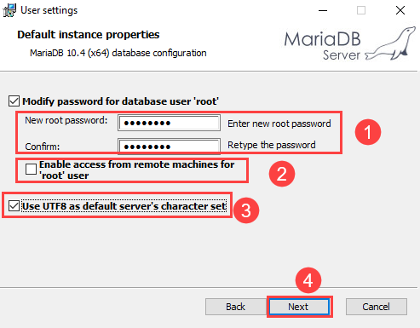

 You will have this window that will pop up , first you’re going to check the box “Install Service “ (the first one) and then write MariaDB for the name, then second check “Enable networking” (the second one) and use 3306 as the port (of course you can change it if you want for your own port) and last just put the same settings as show in the picture below and when you’re done click Next :

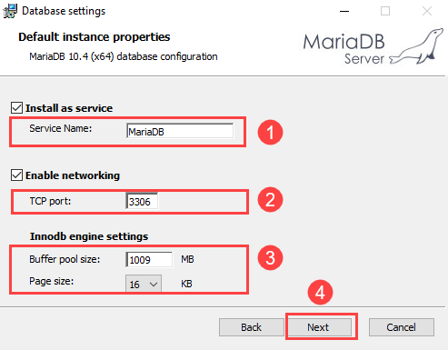

Then click Next until you are here and just hit Install to finish it :



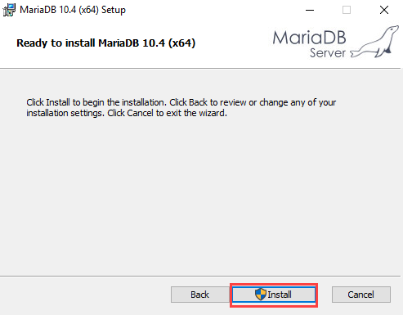

How to use MariaDB :

First of all you’re going to write the name that you entered previously in the research bar on the bottom left corner of your Pc and enter the name that you entered previously as the Service name and something like this should appear (for me the service name is called MySQL) :

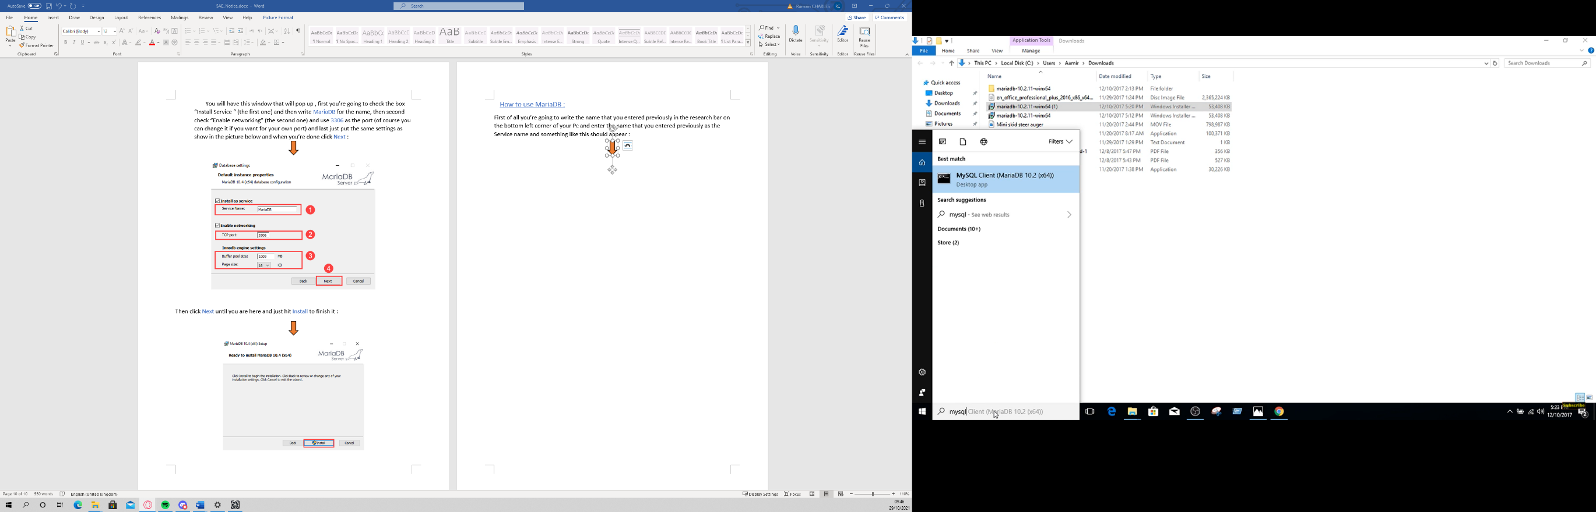

Click on it, after that you will have this and you just have to enter your password :

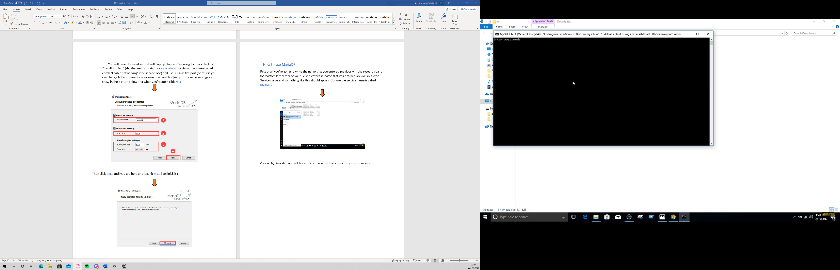

After you typed your password you will end up here and now you’re all set to use MariaDB :



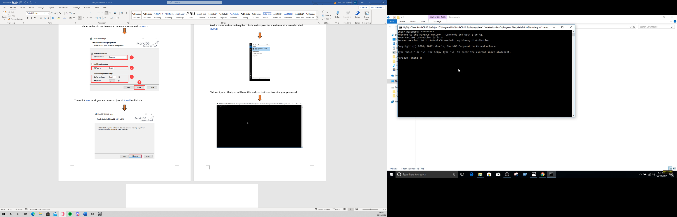



Nginx(Server)

How to install it ?

First off all click on this <http://nginx.org/en/download.html> and you’ll end up on this :

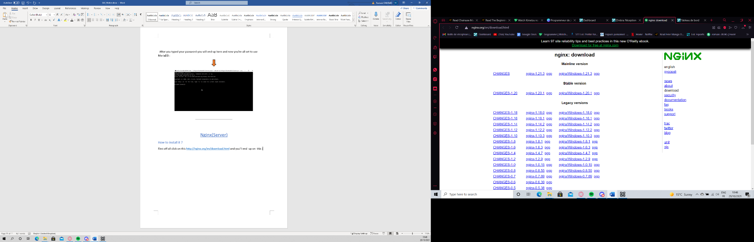

You will choose the same one in the picture below, it will download a zip file :

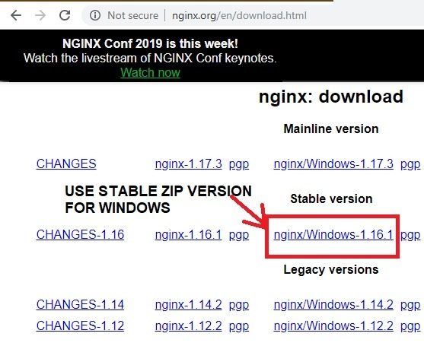

You fill first extract the new folder , and then when your done with it you will move all the files to “Program Files.”:

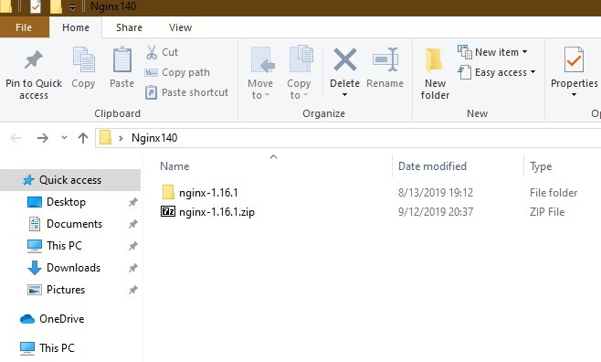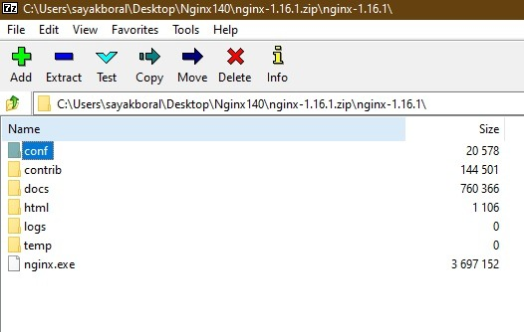

After extracting open this file and then click on “nginx.exe” and it should start downloading:

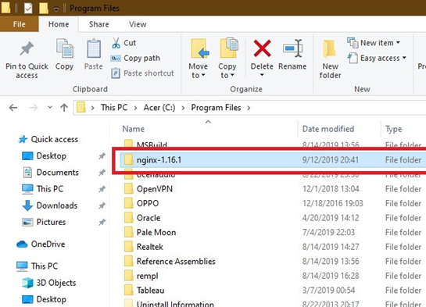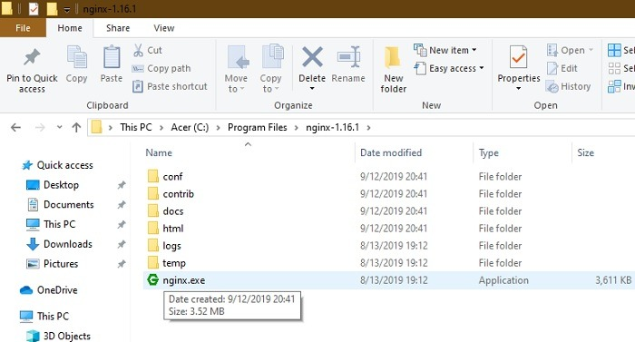

How to use it ?

You can open the Manager directly from the Start menu. Here, you will be able to access the default website, which is usually located  at “inetpub wwwroot.” This is also known as the [web application root](https://docs.microsoft.com/en-us/previous-versions/office/developer/sharepoint-2010/ms474356(v%3Doffice.14)).

It is helpful to change the physical path of this root to a more desirable folder. I created a new “Work” folder in C:\ and changed the physical path to “C:\Work.”

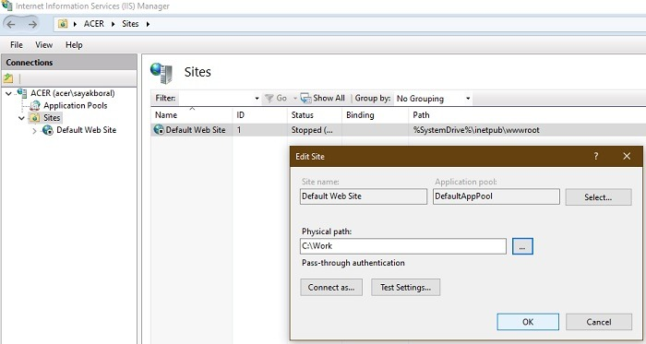

After this rename your folder Nginx . Click “Conf” and select “nginx.conf.” Notepad++ can be use to edit the file , to open with Notepad++ Right-click on the file and “open with” like this :

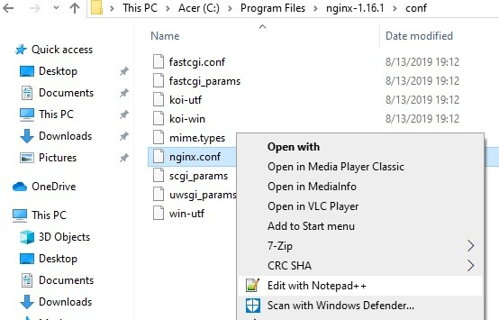

On Notepad++ you will be able to change the root shown in the picture below :

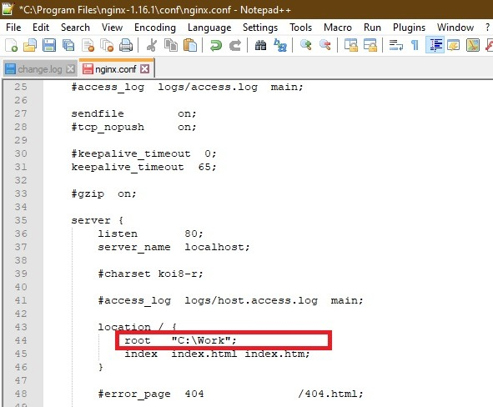



MAMP

How to install it ?

First of all click on this link <https://www.mamp.info/en/downloads/> and then click the on for windows :

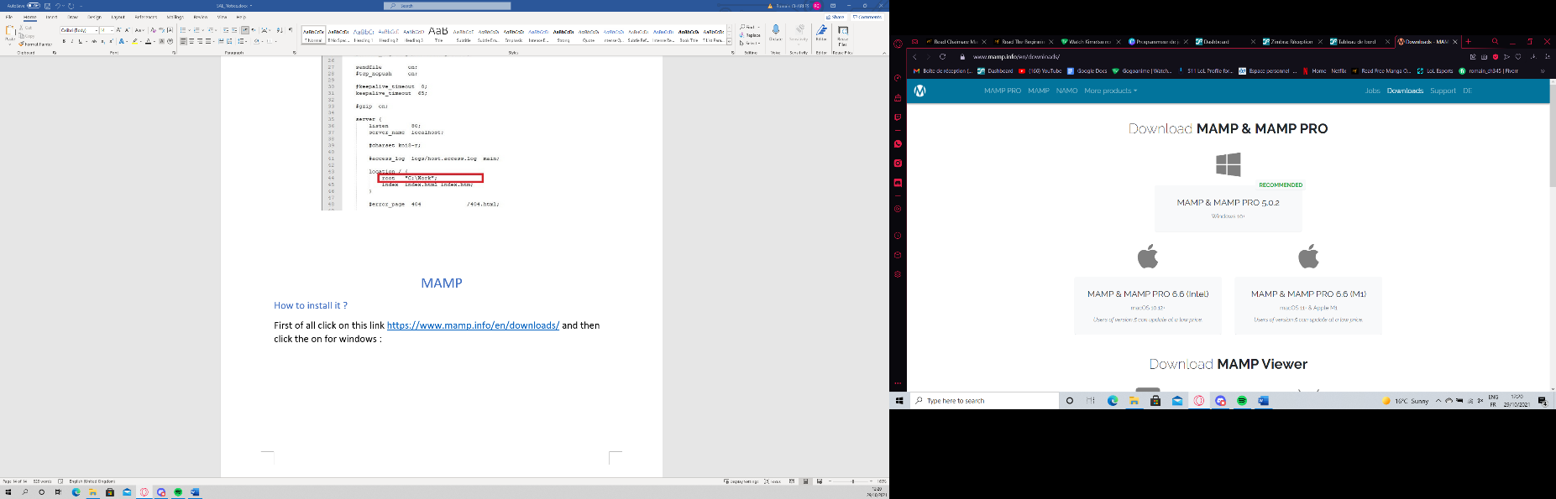

And it will start Downloading on the bottom left corner , once it’s done click on it and you will have this :

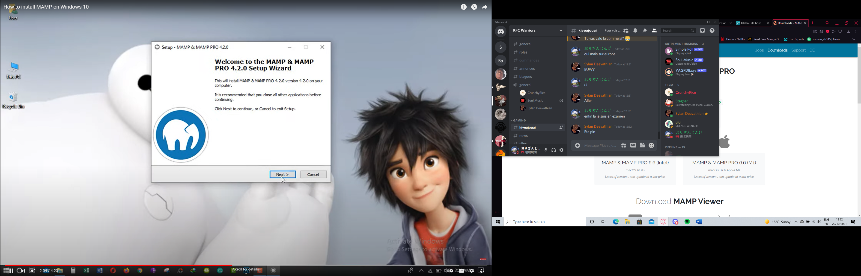

On the next one uncheck both of the boxes and click Next :

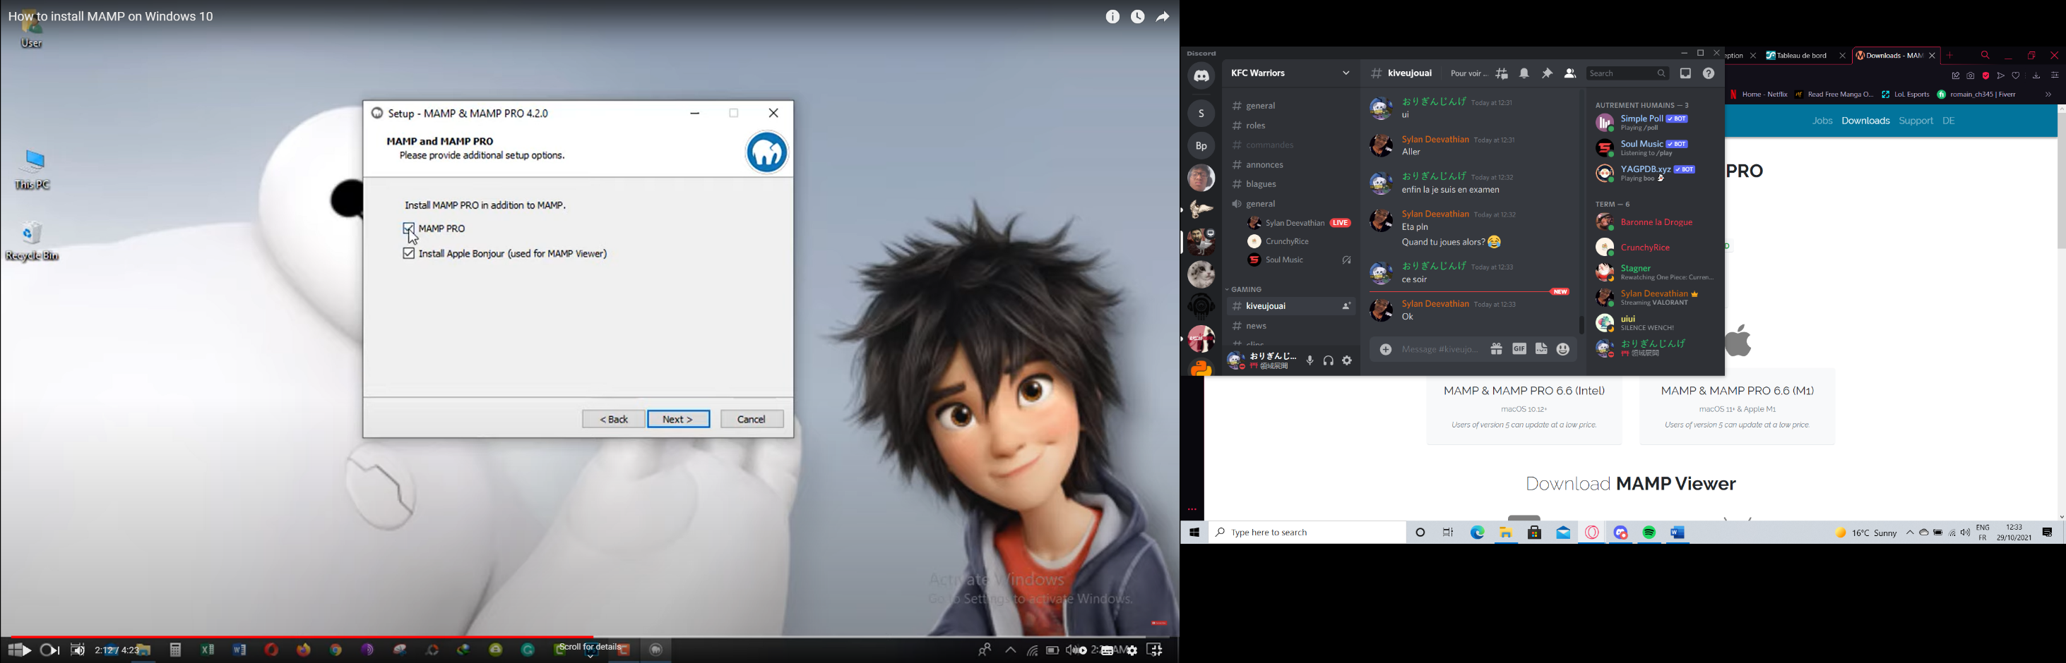

After that you will have the License Agreement , check “I accept the agreement” then Next :

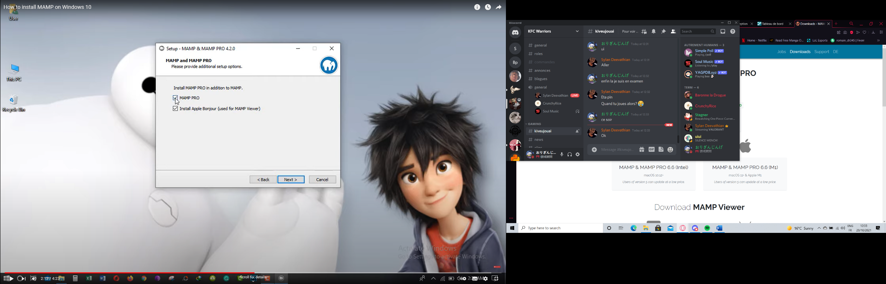

Then click Next until you have this and then click Install :

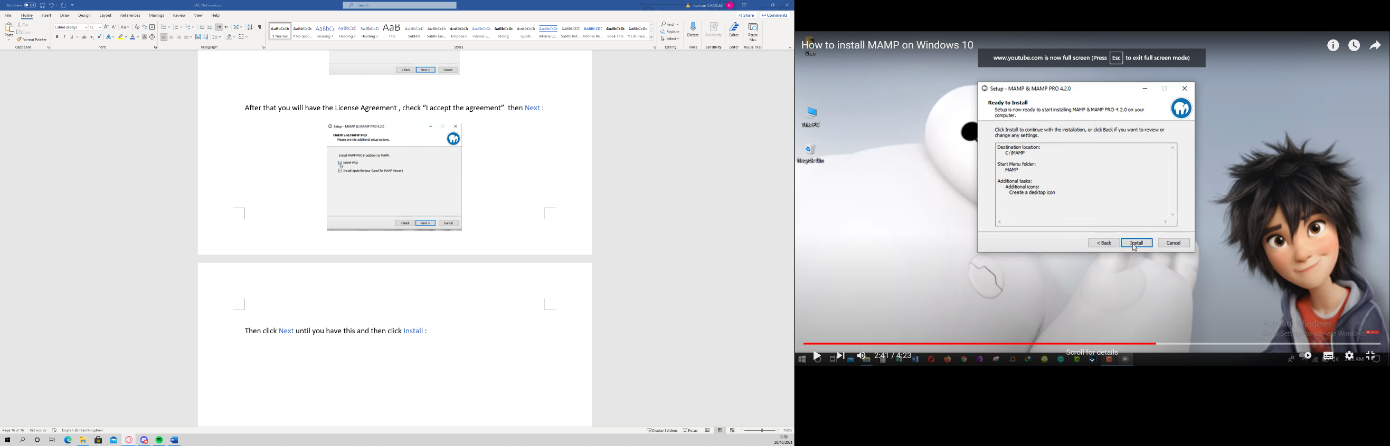

To use it select the port 80:

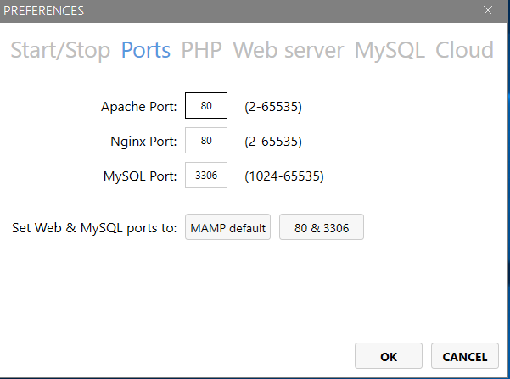

After that put the server on Nginx et change the root for the file on Nginx :

